**Automatic Sliding Door Using PIC 18f452**

**Project Explanation:**

In this project we have to simulate the opening and closing of a automatic sliding door and show the opening or closing status of door on 16x2 alphanumeric Lcd display.For this purpose one dc motor, two push buttons and an lcd along with small componets is used.The basic working of the project is that when the close push button is pressed the motor runs in anti clockwise dirrection and door closed and shows the status on lcd.onthe other hand, when the open push button is pressed the motor runs in clockwise dirrection and door opens showing the status on lcd screen.If both the buttons are un pressed then the lcd displays the name and ID of the student.

**Circuit Diagram:**

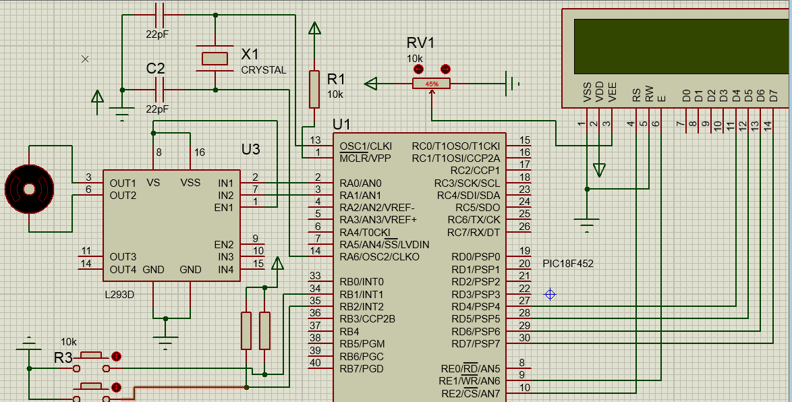

This Circuit diagram shows the connection of PIC 18f452 with the lcd close and open pushbuttons and crystal oscillators and other small components.The crystal frequency for this project was taken as 32Mhz and caacitors used for this are 22pf capacitors.Initially the both input pins which are RB1 and RB2 are kept high by using input pullup resistor.The motor is connected with motor drive and motor drive controlss the dirrection of motor Via IN1 and IN2 and these IN1 and IN2 ins are connected with microcontroller at the pins named as RA0 and RA1.

**Block diagram Of Circuit:**

Controller

16x2 Lcd Display

Pushbutton for close

Motor controling

Push button for open

**Code:**

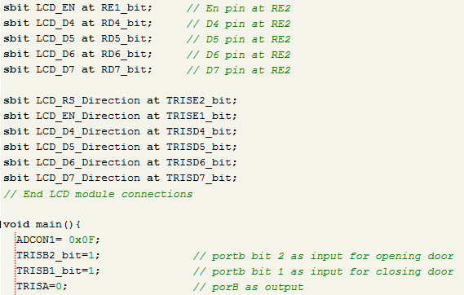

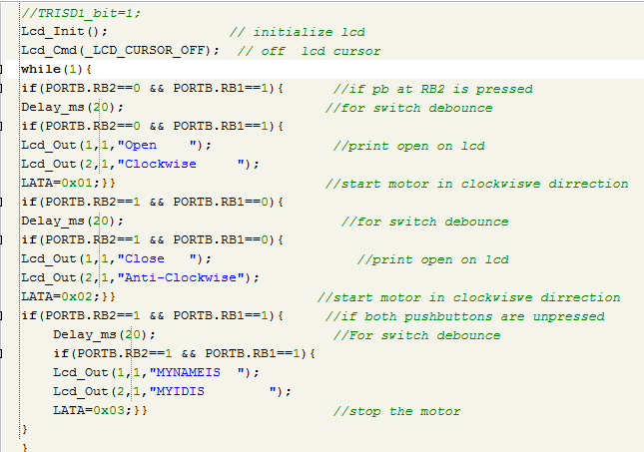

**Explanation how code works:**

**Explanation of I/O ports:**

In the first picture all the initalizations are given.The conections of lcd and pushbutons and motor drive are declared.The data pins of lcd are connected the RD4,RD5,RD6 and RD7 while its control pins are connected to the RE1 and RE2.

Similarly the motor connections are done on the RA0 and RA1 pin s of portA and the pushbuttons are connected to the RB1 and RB2 pins of the portB. The butons are input and all the other things are output.

**Explanation of motor rotaion in clockwise dirrection:**

After initializing the lcd in the if condition we will check if the pb2 is pressed then wait for 20ms as switch debounce and after that the lcd prints the motor is running in clockwise dirrection and we sent the 0x01 to the PortA as 0b00000001 which will keep the IN1 high and IN2 low and by this motor will run in clockwise dirrection.

**Explanation of motor rotaion in Anti-clockwise dirrection:**

In if condition we will check if the pb1 is pressed then wait for 20ms as switch debounce and after that the lcd prints the motor is running in Anti-clockwise dirrection and we sent the 0x02 to the PortA as 0b00000010 which will keep the IN1 low and IN2 high and by this motor will run in Anti-clockwise dirrection.

**Explanaion of logic to display Name and ID:**

When the both switches are unpressed the the motor simply prints the name and ID of the student.for this we have added the library of the liquidcrystal.ha and by this library we have easily done all the things.First we print name on the first row then id on the second row.

**Code Explanation Via Block diagram:**

initalization

while

Print on LCD

Run motor Clockwise

IF PB2 pressed

IF PB1 pressed

Run Anti clockwise

Print on LCD

IF both unpressed

Stop motor

Print on LCD